**Hands-On Activities – Milestone 1**

**Activity 1**: Design an algorithm to accept 25 integer elements for an array then find the maximum number in the set and display it.

**Activity 2**: Design an algorithm to accept 10 integer elements for an array and then find the number of times the number with the maximum value occurs in the array.

For Example – If input elements are: 1, 2, 5, 6, 8, 9, 9, 3, 4, and 2 Output must be 2

Reason: The number with the highest value in the array is 9. It occurs 2 times in the array.

import java.io.BufferedReader;

import java.io.IOException;

import java.io.InputStreamReader;

class Array {

public static void main(String[] args) throws IOException {

BufferedReader bf=new BufferedReader(new InputStreamReader(System.in));

int values[]=new int [5];

for(int i=0;i<values.length;i++)

{

values[i]=Integer.parseInt(bf.readLine());

}

int max=values[0];

for(int i=0;i<values.length;i++)

{

if(max<values[i])

max=values[i];

}

int count=0;

for(int i=0;i<values.length;i++)

{

if(values[i]==max)

count++;

}

System.out.println("maximum number: "+max+"\n"+"maximum number occurance: "+count);

}

}

OUTPUT:

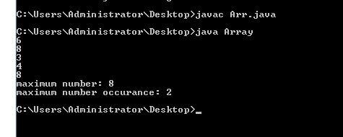

**Activity 4:** Design an algorithm to calculate the factorial of a number N. The value of N is provided as an input by the user.

import java.io.BufferedReader;

import java.io.IOException;

import java.io.InputStreamReader;

class Factorial {

public static void main(String[] args) throws IOException {

BufferedReader bf=new BufferedReader(new InputStreamReader(System.in));

int values;

int fact=1;

values=Integer.parseInt(bf.readLine());

for(int i=values;i>=1;i--)

{

fact=fact*i;

}

System.out.println("Factorial of the number:"+fact);

}

}

OUTPUT:

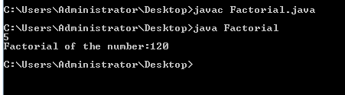

**Activity 5**: Design an algorithm which accepts 10 integer values, calculates the average and prints it.

import java.io.BufferedReader;

import java.io.IOException;

import java.io.InputStreamReader;

class Average {

public static void main(String[] args) throws IOException {

BufferedReader bf=new BufferedReader(new InputStreamReader(System.in));

int values[]=new int [5];

for(int i=0;i<values.length;i++)

{

values[i]=Integer.parseInt(bf.readLine());

}

int sum=0;

int average=0;

for(int i=0;i<values.length;i++)

{

sum=sum+values[i];

}

average=sum/values.length;

System.out.println("Average:"+average);

}

}

OUTPUT:

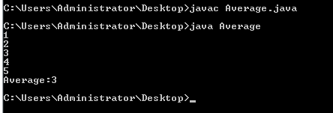

**Activity 6:** Design an algorithm to accept a given string from the user. The algorithm must then remove characters from the string which appear more than once.

For Example – If input string is – Malayalam

The output must be – maly